International Non-profit Accounting Guidance (INPAG)
Exposure Draft 2
Response template
Please use this form to record your responses to the Specific Matters for Comment relating to INPAG Exposure Draft 2
Comments are most helpful if they:
- Address the question asked;
- Contain a clear explanation to support the response provided, whether this is agreeing or otherwise with any proposals made;
- Propose alternatives for consideration, where responses are not in agreement with the proposal made;
- Specify the INPAG paragraphs to which any comments relate; and
- Identify any wording in the proposals that might not be clear because of how they translate.

The text boxes will expand as required. There is no size limit. There are 12 question areas, according to the various sections in INPAG. You do not need to answer all questions and can choose to answer as many or as few as you wish.
You may comment on any aspect of Exposure Draft, not just the specific matters identified. General comments should be added at the end of this document.
Responses must be received by 15 March 2024 and must be in English.
Responses can be submitted to ifr4npo@cipfa.org or through the website at www.ifr4npo.org/have-your-say
Respondent information:
First name: | List of Participants  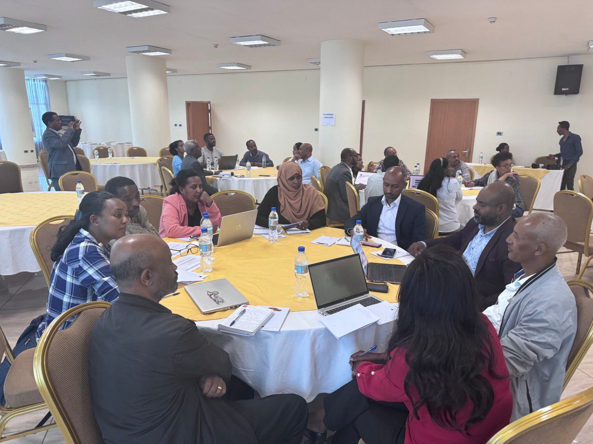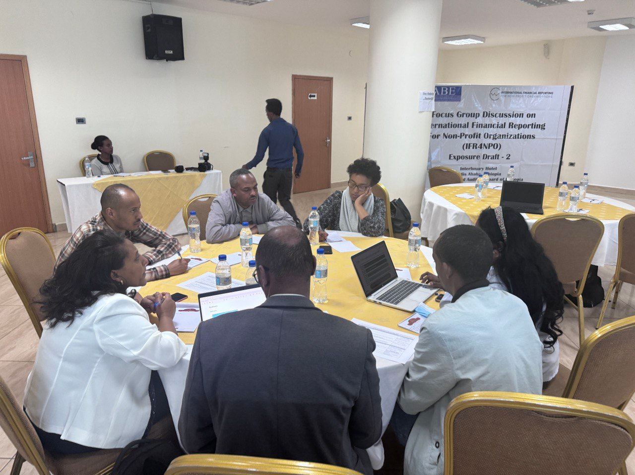
Last name:
Email:
Position:

Please indicate whether you wish to receive further information about this project and consent to being contacted at the email address provided. | Tick boxes  Agree  Disagree

This document has been designed purely to enable feedback to Exposure Draft 2. Participation is undertaken on an entirely voluntary basis. The responses will be used to shape the development of INPAG and not for any other purpose. We ask for your name and contact information to enable us to contact you if we should have any clarifications regarding your responses. Responses will be public, but personal contact information will not be disclosed. Personal information will only be held for the purposes of developing INPAG. You may withdraw your consent for us to hold any of your personal information at any time by contacting us at ifr4npo@cipfa.org
Specific Matters for Comment
Question 1: Financial instruments

INPAG Section 11 provides guidance on the treatment of financial assets and financial liabilities. It has two parts, Part I that addresses simpler financial instruments and Part II that addresses more complex financial instruments. There are no significant changes other than alignment with other sections.
 | References | Response
- Do you agree that there are no significant alignment changes required to Section 11, other than those that have already been made? If not, set out the alignment changes you believe are required. | Section 11 | Majority of participants agree  Those who disagreed suggested more detailed guidance regarding the valuation of certain financial instruments, such as investments of NPOs in Income Generating Activity businesses. These businesses have shares that are not publicly traded, and there are no other means available to measure the value of these assets.

Question 2: Inventories

INPAG Section 13 provides guidance on the recognition, measurement and disclosure of inventories. Major changes have been made to broaden the scope of this section to include NPO specific inventory and set out their measurement, where inventories held for use or distribution to be measured at the lower of cost adjusted for any loss of service potential and replacement cost. It has been modified to allow the use of permitted exceptions where certain donated items are not recognised in inventories. It has also been amended to allow NPOs to expense services to be provided to service recipients for no or nominal amounts as incurred rather than as work in progress within inventories. Disclosures have been updated to address the use of permitted exceptions and where donated inventories cannot be reliably measured.
 | References | Response
- Do you agree with the expansion of Section 13 Inventories to specifically include inventory held for use internally, for fundraising or distribution? If not, why not? | G13.1 | All participants agree
- Do you agree with the permitted exceptions that allow for certain donated inventories and work in-progress that comprises services to be provided for no or nominal consideration to not be recognised as inventory? If not, what would you propose instead/. | G13.2, G13.5 (a)-(c) | Most of them agree. Few of them disagree for the following reason:  NPOs are required to maintain a system for recording inventories on hand at the time of receipt, whether they use software or manual records. When NPOs are ready to use or sell these inventories, no exceptional circumstances would alter their ability to measure the value of the stock reliably. Therefore, the existing exception for recognizing revenue or expenses at the time of use or distribution does not significantly benefit NPOs and is recommended for removal "of recognizing at the time of use or distribution".
- Do you agree that fair value should be used to value donated inventory? If not, what would you propose instead? | G13.7 | Most of them agree.  The practical challenges arise from the difficulty of assigning a value to certain items, especially when the value is provided by a donor. In such cases, the recipient (NPO) may lack the means to independently verify whether the indicated value is truly fair. Donors often require that these values be reported in financial statements as in-kind donations. To address this, an exception could be made to allow the donor-provided value (of the asset) to serve as the basis for measurement when the NPO is unable to estimate it accurately.  Additionally, some suggest that a simpler approach, such as relying on estimates from a management committee or a small team within the NPO, would suffice for many organizations in Ethiopia. This alternative would avoid the complexities and costs associated with the fair value approach.
- Do you agree that inventories that are held for distribution at no or nominal consideration or for use by the NPO in meeting its objectives shall be measured at the lower of cost adjusted for any loss of service potential, and replacement cost? If not, what would you propose instead? | G13.8 | Most of the participants agree  Some of them disagree for the following reasons.  Current replacement cost is often unavailable when donors acquire such inventory items but don't communicate or share the value information. Hence, determining the replacement cost will be difficult for the NPO. For small NPOs, measuring the impairment loss is a daunting task. It is recommended that the inventory value for impairment loss be written down based on the ability of the NPO to measure impairment loss.
- Do you agree with the proposed disclosure requirements, particularly regarding the use of permitted exceptions and where donated inventories are not recognised because they cannot be reliably measured? If not, what would you propose instead? | G13.26 (e), G13.27 | All participants agree

All
 | References | Response
- Do you agree that an illustrative example on warranties is removed from the Implementation Guidance, and a new example on onerous contracts is added? If not, why not? | Section 21, Illustrative example 3 | All of them agree

Question 4: Revenue

INPAG Section 23 has been expanded to specifically cover revenue from grants and donations. It comprises two parts with a preface that contains content that is common to both.

Part I is new material that has been written specifically for NPOs that sets out the requirements for the recognition, measurement and disclosure of revenue from grants and donations. The timing of revenue recognition is dependent on the existence of an enforceable grant arrangement (EGA), which must have at least one enforceable grant obligation (EGO). It follows the concepts in the 5 step model for revenue recognition used in international standards. Part I also describes permitted exceptions for the recognition of gifts in-kind and services in-kind.

Part II reflects the IFRS for SMEs Accounting Standard material for contracts with customers provides It provides simplified guidance for less complex contracts.

 | References | Response
- Section 23 Part I and Section 24 Part 1 introduce new terminology relating to grant arrangements. Do you agree with the terms enforceable grant arrangement and enforceable grant obligations and their definitions? If not, what alternative terms would you propose to achieve the same meaning? What are the practical or other considerations arising from these definitions, if any? | G23.23-G23.30, G24.3-G24.4 | Most of the participants agree with the concept.  Key practical considerations are:  - Grant Agreements and Recipient Rights: Most grant agreements primarily focus on the rights and obligations of the fund recipients. However, there is often no mechanism in place that allows the grant recipient to enforce these rights. This situation holds true even for major donors like USAID, the EU, or DFID. In some cases, these donors may cease funding due to policy changes in their home countries, although such conditions might not be explicitly outlined in the grant agreement.  - Grant Articles and Funding Availability: Donors, including UN agencies that rely on other donors, sometimes include specific articles in their grant agreements, such as "..subject to fund availability). However, funding availability becomes a critical factor. Under these circumstances, it becomes challenging to ascertain the rights and obligations of both the donor and the NPO are present in the agreement.  - Challenges in Determining Funding Arrangement Type : Determining EGO can be complex because grant agreements are often not crafted with explicit consideration of EGA or OFA.  It is proposed to include guidance on whether a disclaimer of donors for terminating the agreement due to funding loss (but not without the failure of the recipient NPO) in the grant agreement implied that the grant agreement is not EGA, as one of the parties do not have obligations because of such disclaimers.
- Do you agree with the structure of Section 23, with Part I focused on grants and donations, Part II focused on contracts with customers and a preface that brings together the key principles and information about how to navigate the guidance? If not, what changes would you make and why? | Section 23 | All participants agree
- Do you agree that revenue is only deferred where the grant recipient has a present obligation in relation to the revenue received? If not, in what other circumstances could revenue be deferred and what is the conceptual basis for this proposal? | G23.27, G23.41-G23.59 | Most of the participants agree.  Some objected to the idea because, at least to the minimum, the NPO may have a reporting accountability for using the fund, though there is no identifiable EGA. In such a case, it is rather OFA. As indicated earlier, reporting is an administrative requirement that doesn't constitute an EGA. There is no present obligation to the NPO and no point in deferring revenue recognition as there is no outstanding EGO other than reporting, which is not considered as EGO.
- The revenue recognition model for enforceable grant arrangements requires that revenue is allocated where there is more than one enforceable grant obligation. Do you agree with the allocation methods identified? If not, what methods would you propose? What are the practical considerations? | G23.53-G23.56, G23.125-G23.138, AG23.52-AG23.59 | All participants agree
- Do you agree with the permitted exceptions that allow the recognition of some gifts in-kind, either when sold, used or distributed, and that these permitted exceptions cannot be used where donations are received as Part of an enforceable grant arrangement? If not, what would you propose instead and what is the rationale? | G23.36, G23.37 | Most of them agree  Some of them disagree and propose as follows:  - The ability to measure the fair value of items is not dependent on the nature of the grant arrangement. Hence, the exception should apply to all types of funds.  - Measurement at the time of use or distribution may not be practical as the realities of the inability to measure will not be changed from the date on which the NPO receives the items.
- Do you agree that services in-kind are not required to be recognised unless they are mission critical? If not, on what basis should services in-kind be recognised and what is the rationale? | G23.36, G23.38, G23.63, AG23.35-AG23.36 | Some of them agree,  Some of them do not agree that financial management, admin, and other areas of the NPOs are vital for the sustainability of the NPO. Hence, the exception for non-mission critical should be removed, and all material and applicable service in kind need to be incorporated so that the user of the financial statements can get the complete picture of the performance of the NPO.
- Do you agree that donations in-kind (both gifts in-kind and services in-kind) should be measured at fair value? If not, what would you proposed instead? | G23.31-G23.32, G23.35-G23.38 | Many of them agree  Concerns are the burden to NPOs in applying fair value measurement, especially when there is no market for the asset received or no equivalent items to compare with. Those who don't agree to propose an estimation by a management team will suffice the purpose.
- Do you agree that administrative tasks are generally not separate individually enforceable obligations, but a means to identify or report on resources in an enforceable grant arrangement? If not, provide examples of where administrative tasks are an enforceable obligation. | G23.49 | Most of them agree  Some of them indicated that the guideline should be principles-based instead of rule-based. If we exclude administrative requirements, it amounts to a rule. In some situations, failure to comply with the administrative requirements results in a funding cut or cancellation of the grant agreement or may be used as a key deliverable to submit the next trench. Hence, if an administrative procedure is considered in the grant agreement as a key milestone for the release of funds, then it should be considered an EGO.
- Do the proposals for disclosure of grant revenue provide an appropriate level of transparency? If not, what would you propose and what is the rationale for your proposal? | G23.61-G23.70 | All participants agree
- Part I is written for simpler grant arrangements and Part II includes a paragraph for simpler contracts with customers. For more complex grant arrangements, additional guidance is provided about how to apply Part II in the NPO context. Do these proposals successfully remove duplication, help understandability and the ability to implement? If not, what would you change and why? | G23.42-G23.59, G23.73, AG23.37-AG23.40, AG23.62 | Most of them agree  However, some indicated the following concerns  International NGOs operating in developing countries, like Ethiopia, are reporting entities in their country. The country's jurisdiction requires them to provide an audited financial report for their in-country operation. Some of these international donors conclude grant agreements at their headquarters, and the country office may not have a direct interaction with the donor. Funds are transferred from the HQ to the country office. The practice is vary from NPO to NPO. Some country offices (Branch NPOs) record it as revenue upon receipt; others recognize it as liabilities and later transfer it to expense when they incur it.  This guideline does not guide how to recognize revenue transfers from an HQ (where that grant agreement can be an OFA or EGA).
- Do you have any other comments on the proposals in Section 23, including whether the full content of the IFRS for SMEs section on revenue from contracts with customers in Part II is necessary for NPOs? If so, provide the rationale for the comment and cross reference to the relevant paragraphs. |  | Some of them recommended that additional guidance should be provided in determining whether a grant agreement is EGA or OFA, with model examples to avoid inconsistency in the application of the guidance. Revenue and expense determination, as well as other items in these standards, are largely dependent on whether the agreement is EGA or OFA. Hence, the simple criteria indicated (the four criteria, what grant obligation means etc.) might not be helpful when reviewing actual grant agreements. Hence, it is vital to provide illustrative guidance to determine whether a funding arrangement is an EGA.

Question 5: Expenses on grants and donations

INPAG Section 24 is new and covers accounting for expenses. Part 1 of this Section covers Expenses on grants and donations. Guidance covers the recognition, measurement and disclosure of grants that an NPO makes to other entities or individuals. As with Section 23 Part I, it has a model for recognising expenses on grants and donations that depends on the existence of an EGA.
 | References | Response
- Section 24 Part I and Section 23 Part 1 introduce new terminology relating to grant arrangements. Do you agree with the terms enforceable grant arrangement and enforceable grant obligations and their definitions? If not, what alternative terms would you propose to achieve the same meaning? What are the practical or other considerations arising from these definitions, if any? | G24.3-G24.4, G23.23-G23.30, | Most of them agree with the need to classify funding.  Some of the practical concerns are:  - Due to the variation of grant agreements, even within a single donor, the determination of EGO will remain a challenge unless donors are considering redefining grant agreements  - Some NPOs working with large donors, such as USAID, are familiar with a grant type such as "Cooperative Agreements" or "Contract Mechanisms". Contract mechanisms have different kinds of arrangements.  Hence, determining whether an agreement is an EGA or OFA will be a challenge to the NPOs  Large donor groups must streamline their standard grant agreements to fit the proposed guidelines.
- Do you agree that all expenses on grants and donations can be classified as an enforceable grant arrangement or as an other funding arrangement? If not, provide examples of which expenses on grants or donations would not fit in either of these classes, and why not? | G24.3-G24.6 | All participants agree with the above concern.
- Enforceable grant arrangements are required to be enforceable through legal or equivalent means. Do you agree that regulatory oversight and customary practices can be sufficient to create an enforceable grant arrangement? If not, why not? What weight should be applied to these mechanisms? | G24.3, AG24.9, AG24.13-AG24.15 | Some of them agree, and others do not.  - Some of the participants indicated that the "regulatory oversight" should be removed as the regulatory bodies' role is not to enforce grant agreements, and this is unlikely to happen in the case of Ethiopia. The mandate of regulatory bodies is mainly for the NPOs operating in Ethiopia and is not mandated for donors who are operating outside the jurisdiction.  - Others also indicated that there is no such customary practice in Ethiopia where it enforces such grant agreements.
- Do you agree that the full amount of the grant (including where it covers multiple years) should be recognised as an expense if the grant-provider has no realistic means to avoid the expense? If not, under what circumstances should a grant-provider not recognise the full expense and what is the rationale? | G24.17-G24.18, AG24.24-AG24.27 | Some agree and others do not agree.  - Some suggested that it should be on a progressive basis as the work is done. It doesn't make sense to recognize the total amount as an expense while the work has been in progress for several years by the NPO.  - Some indicated that the matching principle should be applied, though others disputed this as EGOs may not necessarily align with the amount of expense to be recognized.  - Normally, if the grant recipient fails to use the fund over the years, the grant provider has several ways to make the NPO accountable for the money.
- Do you agree that grants for capital purposes are expensed by the grantor using the same principles as other grants? If not, why not? What would you propose instead? | AG24.30-AG24.35
- Do the proposals for disclosure of grant expenses, which include a sensitive information exemption, provide an appropriate level of transparency? If not, what would you propose and what is the rationale for your proposal? | G24.32-G24.41 | Most of them agree  Those who disagree indicated that the exception would allow the management to be restrictive in disclosing information that may be relevant and useful for the report users but not affect any third party.
- Do you agree that a grant-providing NPO with an OFA can only recognise an asset at the point that a grant recipient has not complied with a constraint on the use of funds provided? If not, what would you propose instead? | G24.11 | All participant agree
- Do you have any other comments on the proposals in Section 24, including that administrative tasks in an enforceable grant arrangement are generally not an enforceable grant obligation but a means to identify or report on resources. If so, provide the rationale for any comments and cross reference to the relevant paragraph. | Section 24  IG24.21 | Most of them agree  Some indicated that reporting is one of the main parts of donor accountability. The ability to produce financial reports, including physical reports, helps the donor monitor the NPO's performance. Hence, administrative reporting should be considered an "EGO". In addition, it has become a tradition with some donors that reporting is Part of the milestone for fund release.

Question 6: Borrowing costs

INPAG Section 25 specifies the accounting for borrowing costs. There are no significant changes with modifications made to align with other sections.
 | References | Response
- Do you agree that there are no significant alignment changes required to Section 25, other than the terminology changes that have been made? If not, set out the alignment changes you believe are required. | Section 25 | All participants agree

Question 7: Share-based payments

INPAG Section 26 specifies the accounting for share-based payments. As share-based payment transactions are considered highly unlikely for NPOs this section has been removed and a paragraph included to explain why it is not Part of INPAG.
 | References | Responses
- Given the characteristics of NPOs, do you agree that guidance on share-based payments is not required? If not, provide examples of share-based payments and explain how they are used. | Not applicable | All participants agree

Question 8: Employee benefits

INPAG Section 28 covers all forms of consideration given by an employing NPO to its employees. Changes have been made to this Section to remove references to share-based payments and to profit-sharing arrangements as these are not expected to be Part of NPO remunerations structures. Amendments describe how a controlling NPO providing benefits to employees of controlled entities in the group can apply its provisions.
 | References | Responses
- Do you agree that profit sharing and share-based payments are removed from Section 28 Employee benefits to reflect that employees of NPOs are very unlikely to be incentivised by sharing in the surpluses made by an NPO? If not, provide examples of such arrangements used by NPOs. | G28.3, G28.27 | All participants agree
- Do you agree that in-year changes to the value of post-employment benefits can be shown on either the Statement of Income and Expenses or Statement of Changes in Net Assets? If not, why not? | G28.21 | Most of them agree  - Some participants proposed that defined benefit plans be included in the statements of changes in net assets, aligning with other standards."  - Advocates for their inclusion in the income and expense statement argue that the annual report should reflect the expenses related to defined benefit plans so that the report user gets the complete picture.

Question 9: Income tax

INPAG Section 29 addresses the accounting for income tax including current and deferred tax. Minor editorial amendments have been made to align with other Sections. Amendments include the removal of the exclusion relating to government grants as this is now replaced, and to allow the tax expenses to be shown in the Statement of Income and Expenses or Statement of Changes in Net Assets as appropriate.
 | References | Responses
- Are there any elements of Section 29 Income taxes that are not required by NPOs? If so, explain which elements are not needed and why. | Section 29 | All participants agree

Question 10: Foreign currency translation

INPAG Section 30 describes how to include foreign currency transactions and foreign operations in the financial statements. This Section has been amended to require that the exchange rate gains or losses on monetary items are presented consistently with the transaction to which they relate.

This Section also requires that deficits or surpluses arising as a consequence of changes in exchange rates for grant arrangements that are included as Part of funds with restrictions are disclosed. This is to provide transparency of exchange rate exposures relating to grant arrangements.

 | References | Response
- Do you agree that grants and donations should be considered when setting the functional currency? If not, why not? | G30.3 (c), G30.5 (b), G30.5 (d) | All participants agree
- Do you agree with the principle that exchange gains and losses are shown as Part of funds without restrictions unless they relate to a transaction that is to be shown as restricted? If not, why not? | G30.12, G30.20 (c) | All participants agree
- Do you agree with the proposal to require exchange gains and losses that contribute to a surplus or deficit on grant arrangements presented as funds with restrictions to be disclosed? If not, why not? What would you propose instead? | G30.30 | Most of them agree  Those who dissent pointed out that certain NPOs may maintain a joint bank account, complicating individual funds' assessment of gains or losses and classifying them as restricted and non-restricted.
- Do you have any other comments on Section 30, including whether there are any NPO-specific recognition and measurement issues associated with foreign currency translation? If so, explain your comments and the NPO-specific recognition and measurement issues. | Section 30 | Several participants highlighted the challenge of handling foreign currency accounting, mainly due to differences among donors in how they treat gains and losses. The suggested adjustments and fund allocations after cash transfers could pose an accounting burden for non-profit organizations (NPOs). Despite varying donor policies regarding currency gains or losses, some participants recommended adhering to guidelines from IPSAS or IFRS for SMEs, allowing any donor claims to be recognized as expenses by the reporting date.

Question 11: Hyperinflation

INPAG Section 31 describes the requirements where an NPO is operating in a hyperinflationary economy. Minor editorial changes, including those relating to the structure and names of the financial statements have been made.
 | References | Responses
- Do you agree that there are no significant alignment changes required to Section 31, other than the terminology changes that have already been made? If not, describe any further alignment changes required. | Section 31 | All participants agree

Question 12: Events after the end of the reporting period

INPAG Section 32 sets out the principles for recognising, measuring and disclosing events that happen after the end of the reporting period. Minor amendments have been made to include grant providers as a source of bankruptcy, to remove some references including to profit sharing and dividends. Those with the power to amend the financial statements after they have been issued has also been widened given the nature of NPOs.
 | References | Responses
- Do you agree that there are no significant changes required to Section 32, other than those that have already been made for alignment purposes? If not, describe any further alignment changes required. | Section 32 | All participants agree

General Feedback
Please share any other comments that you wish to raise on Exposure Draft 2.  When providing additional feedback please reference the paragraph numbers, where possible and provide a short explanation to support your comments. | Having a benchmark is crucial for determining which non-profit organizations (NPOs) should adopt INPAG. While the specific threshold may differ across countries, the guidance should underscore the importance of having a threshold to prevent reporting requirements from becoming overly burdensome when implementing INPAG for NPOs in specific jurisdictions.

Both sections include the following question, which you can answer under either section, or cover the grantor and grantee perspectives separately.
Both sections include the following question, which you can answer under either section, or cover the grantor and grantee perspectives separately.

