**Steps to add the Supporting INPAG badge to your LinkedIn Profile**

**Step 1:** Log into your LinkedIn Account.

**Step 2:** Open a new tab and go to the “Support us” [page](https://www.ifr4npo.org/support-us/) on the IFR4NPO website.

**Step 3:** Click on the “Add to profile” button next to the INPAS Badge. This will take you to the *Add license or certification tab*on your LinkedIn profile.

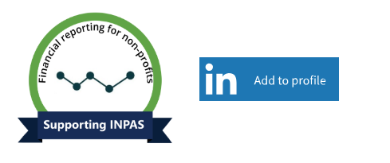

**Step 4:** Make any edits as needed and click the “Save” button to add the certification to your profile.

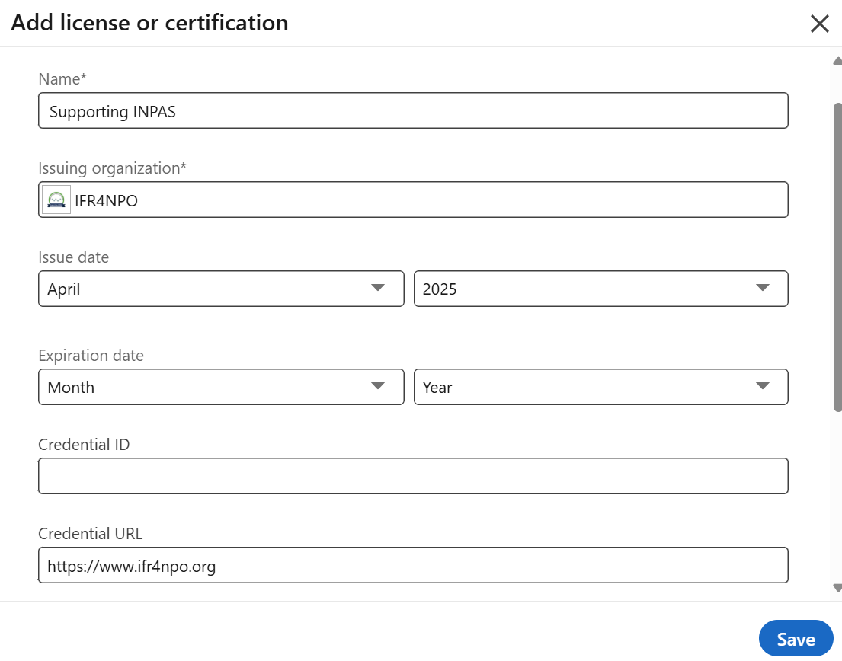

**Step 5:** To share, **click next**, which generates a default message and image.

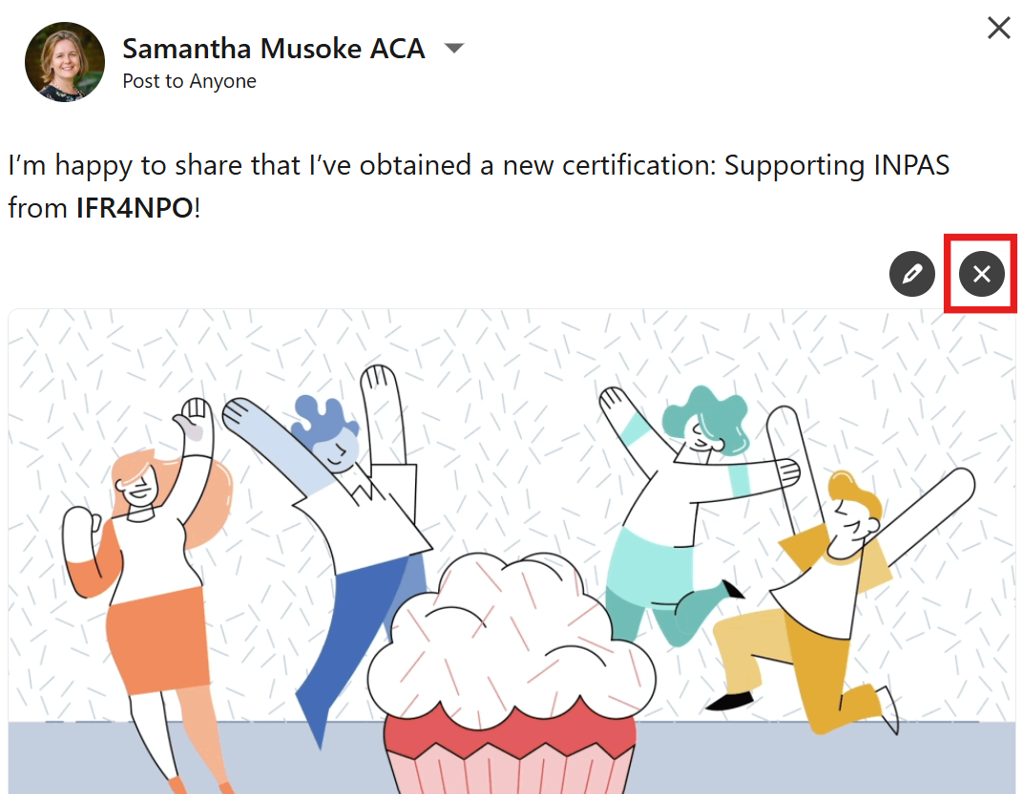

**Step 6**: Click on the black ‘X” to delete the default image.

**Step 7:** Download this [**image of the badge**](https://www.ifr4npo.org/wp-content/uploads/2025/04/Supporting-INPAS-badge-light.jpg)**.** Then click the ‘add photo’ icon and select the badge image.

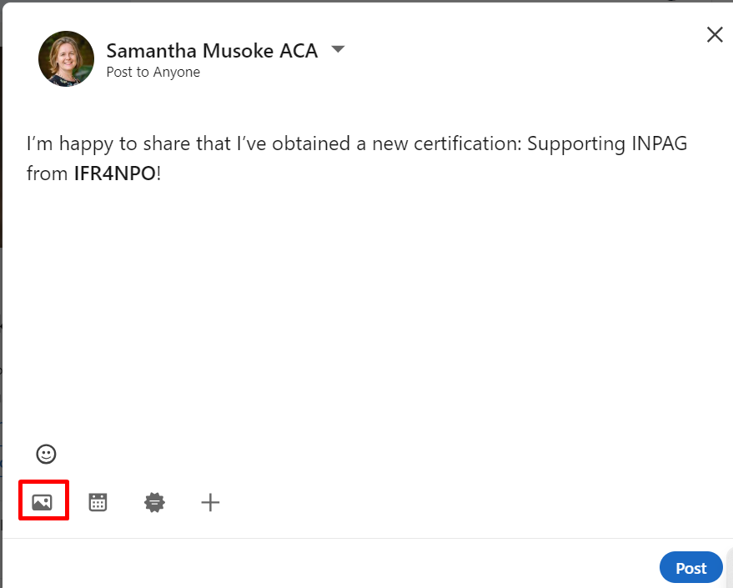

**Step 8:** Craft your message, and post.

Use your own words – or use the message below.

I am proud to support INPAS (international Non-Profit Accounting Standard) and share the vision of a world where social-good organisations leverage transparent, harmonised financial reporting to enhance their impact and secure sustainable funding. @IFR4NPO

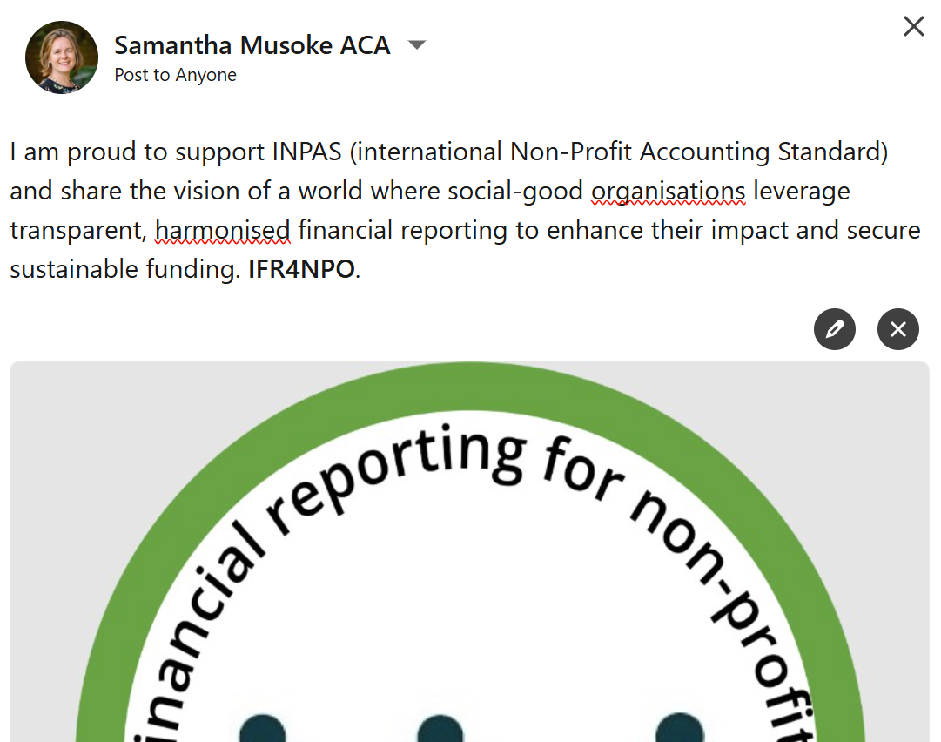

Thank you :-)

If you encounter any issues during the process, please send a message directly to us via LinkedIn (*this button is at the top right corner of your screen when you visit the IFR4NPO LinkedIn page*) or [email](mailto:%20info@ifr4npo.org) for additional assistance.

